**Training Package**

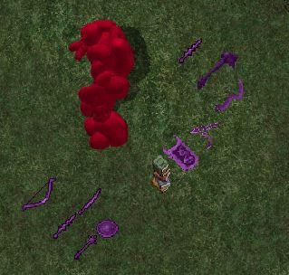

**Training Weapons**

The original weapon pack was posted to RunUO on 18AUG2005 by Triple. http://www.runuo.com/community/threads/training-weapons.57430/

It included:

Training Katana  
Training Kryss  
Training Mace  
Training Bow

All the items are purple, labeled as 'Training Weapons', and do no damage. They are just good for training. I added a buckler to train parry. Then when I made a Gargoyle character I made Gargoyle training weapons. So now the pack has the original 4 weapons and the 6 that I made:

Training Buckler

Training Gargish Boomerang

Training Gargish Kryss

Training Gargish Mace

Training Gargish Shield

Training Gargish Sword

I had to work on them some to get all the Special Abilities to work. Now you can use your specials to get your mana down, so you can work your Meditation and Focus while training fighting skills.

**Training Elemental**

Training Elemental script - not mine, but useful. I was looking for the source and found the same script released with 3 different names... so I am unsure who actually wrote it (it was not me). They are all very similar but a few lines are rearranged. The one I use is from jjarmis, but I found others by Sephiroth, and Murzin. So, whoever wrote it originally - Good job!

Anyway, I put the Training Elementals on a spawner, even though they do not die. I have another spawner that spawns the training weapons on the ground around them. As written you can GM all your fighting skills. I suppose someone could put in a skill cap? I like em like they are.

**Craft Trainer**

Created by "Ashlar, beloved of Morrigan"

The craft trainer is a set of books you can click on and get a gump to choose a skill to train. The skill gain seems to work like regular gains. Easier & faster at low skill, slower and more carpal tunnel inducing at higher levels. Ha ha.

All four settings discussed below are changeable in-game, using the items 'prop' menu.

From the craft trainer release notes:

This is an item/gump which allows players to raise their crafting skills without using resources or producing masses of crafted items.

**MinSkill** is the minimum amount of skill required in that skill before the item is usable.

**MaxSkill** is the maximum amount of skill that the player can have in the skill and still use the item.

**Ouch** is the fatigue factor. Deals damage to stamina and hits during study.

**StudyTime** is the amount of time between study attempts. (when to resend the gump)

I wanted to release my training weapons and it made sense to me to include the whole pack. So here are the weapons, elementals, and school books.

Tukaram 21MAY2016